**WELCOME TO**



**2025**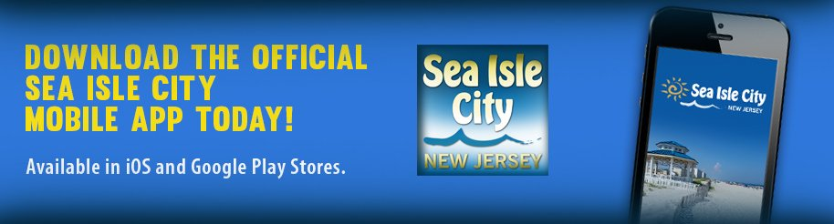

**Download the Sea Isle City Reference Guide**

**At www.visitsicnj.com**

**Emergency Contact**



**Scott Weiner 201.390.4113**

**Jean Weiner 201.543.8537**

**E-mail:** [**hp2srq@gmail.com**](mailto:hp2srq@gmail.com)

**Visit my website at www.3184sic.com**



**Check-in time is 1:30 PM**

**Check-out time is 10:00 AM**

**The garage door will be open upon your arrival. A key will be left on the kitchen island (unless other arrangements have been made with owner). If you need an additional key please let me know.**

**WiFi Access**

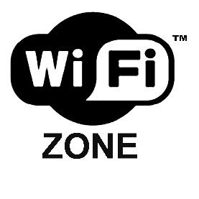

The WiFi Network available is: **Livin_the_Dream**

The password is: **Furnished upon Check-in**

_____________________________________________________________________________________

**Garage door opener**

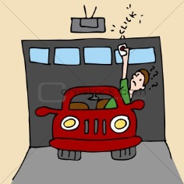

**The code for the outside garage door keypad will be sent to you via email prior to check-in or furnished to you upon check-in.**

______ ______________________________________________________________________________­­­

**Beach Tags**

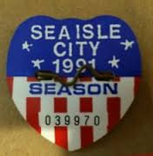

**Ten (10) beach tags** have been provided for your use and can be found hanging on the hook by the front door. Please leave the beach tags on the belt and take the entire belt to the beach.

Thirty dollars ($30) will be deducted from your Security Deposit for each beach tag not returned or replaced prior to check-out.

**Air Conditioning**

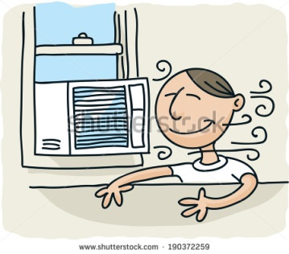

Thermostats are located on the 2nd floor hallway and 3rd floor

**Please make sure all windows and sliders are closed when running air conditioning.**

Set thermostat on both the 2nd and 3rd floors to 76 degrees when checking out

**House Safety**

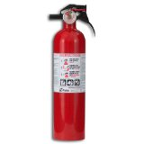

**Fire Extinguisher locations**

1st Floor – On wall by garage steps

2nd Floor – Inside Laundry Room

3rd Floor – Inside Kitchen Pantry

**Please clean the lint trap in the dryer before and after each use to prevent buildup and possible fire.**

**Absolutely NO SMOKING on the property including outdoor decks.**

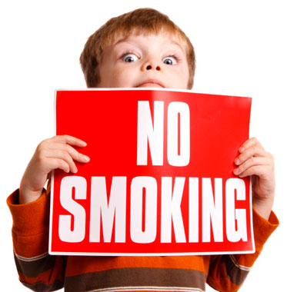

**Beach Chairs**

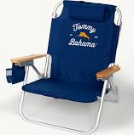

Beach chairs have been provided for your use. They can be found in the garage. Please rinse the sand off of them after returning from the beach.

**Elevator Usage**

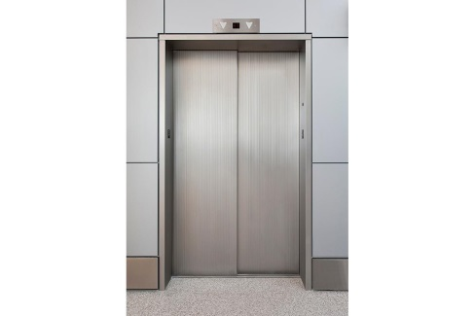

**Please supervise your children at all times when using the elevator.** The elevator is certainly not a toy and we don’t want any accidents.

If both gates in the elevator are not closed or if the door in the room you entered the elevator from is not closed the elevator will not run.

You will not be able to call for the elevator from a different floor if both gates in the elevator are not closed or the door on the floor the elevator is on is not closed.

Try to get in the habit of closing the gate in the elevator and the door when exiting the elevator. If will save lots of aggravation.

**2026**

It’s never too early to start thinking about next summer. Please let us know if you would like to book your

same vacation week for next year. We want to give our returning guests the right-of-first refusal before

turning the week over to local real estate agents.

**Trash Collection and Recycling**



Trash and comingled recycling is collected weekly on **Tuesday** and **Friday** during summer months. Trash cans and recycling containers should be placed curbside as early as 6pm on the day prior to pick-up or as late as 6am on the scheduled collection day. Plastic bags are not to be placed curbside.

Beginning the 4th Monday of September, trash and recycling is only collected on Tuesday.

**Recycling is mandatory in Sea Isle.**

Recycling is not required to be separated. Place all recycling in one of the two provided recycling containers.

**What constitutes recyclables?**

* **Paper:** Newspapers with inserts, office paper, junk mail, brown paper bags, magazines, cardboard, beer and soda carriers, tissue and powdered-detergent boxes
* **Plastic:** #1 through #7 plastic bottles and containers: food, beverage, health and beauty containers, cleaning products and other rigid plastic containers.
* **Metal:** Aluminum and steel (tin) food, beverage and aerosol cans
* **Glass:** Food and beverage glass containers including clear, green or brown bottles, jars and jugs

**Please do not recycle:**

* Food contaminated boxes
* Styrofoam packaging
* Polystyrene egg cartons
* Wax-coated cardboard boxes
* Beverage cups
* Plastic bags

**Beach Information**

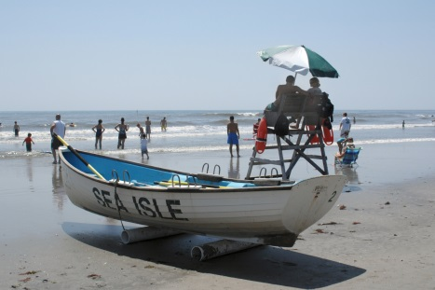

**Beach tags** are required, for everyone 12 years of age and older, for all beaches from Memorial Day Weekend through Labor Day.

**Ten (10) beach tags** have been provided for your use and can be found hanging on the hook by the front door. When you check out please leave them in the same place for our next guests. If you should lose any beach tags, please replace them. The Beach Tag Office can be found at 300 JFK Boulevard or you can purchase them from Beach Tag Inspectors that walk the beach. Thirty dollars ($30) will be deducted from your Security Deposit for each beach tag not returned or replaced.

Lifeguards are located locally on the 84th Street beach as well as the 81st Street beach.

The surfing beach in the area is the 82nd Street beach.

Beach Volleyball can be found on the 88th Street beach.

Alcohol consumption is prohibited on the beach as well as all public areas in Sea Isle.

Smoking is prohibited on the beach.

Surf chairs are available at the 44th Street Beach Patrol Headquarters.

Advance reservations are highly recommended by calling 263-3655, 10am – 4:30pm.

There is a public restroom on the 85th Street Beach as well as a park for small children adjacent to the restrooms.

There is also a hot dog vendor adjacent to the 85th Street restrooms for a quick lunchtime snack. Watch the seagulls. They are aggressive and will try to steal your food.

**Leave the sand at the beach**

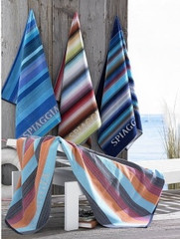

We ask that everyone that visits the beach rinse off the sand from their bodies (especially their feet) before entering the house.

Hoses are located by the garage door in the front of the house and at the rear of the house.

An outdoor shower is located at the rear of the house.

Please don’t bring your sandy beach towels into the house.

**Please** give them a quick shake and hang outside on the line.

**Don’t hang beach towels or clothing from the deck railings.**

Before doing wash, please rid your clothes and towels of as much sand as possible. Sand can clog the system preventing it from not running properly.

Please do not sit on the furniture in wet bathing suits and clothing.

**Check-out Check List**



**Please depart by 10 am so we can prepare the house for our next guests.**

**Kitchen:**

* Refrigerator cleaned out
* Load and run the dishwasher
* Trash can emptied and liners replaced
* Floor swept
* Remove all perishable items. If you want to leave unopened non-perishable items for the next tenant, feel free to do so.

**Bedrooms:**

* Beds made
* Start washing king size sheets
* Drawers checked for personal belongings
* Floors swept

**Bathrooms:**

* Toilet, sink and tub rinsed out
* Trash cans emptied
* Floors swept

**General:**

* All floors swept
* Trash recycled in proper containers
* Trash removed and trash liners replaced
* Deck swept
* All furniture properly arranged
* Clean gas grill when finished (while hot)
* Remove all personal belongings (do you know plug-in chargers are the items most often left behind?)
* Turn off lights, ceiling fans or other electronics
* Doors locked and keys returned to Real Estate agent (if you rented through them) or leave the keys on the kitchen island if you rented directly from owner.

**Thermostat:**

1. Set thermostat on the both the 2nd and 3rd floors to 76 degrees

**Have a safe trip home. We hope to see you again next year.**